**University of Technology and Applied Sciences**

**IT Department**

Course Code: **CSDS3105** Course Title: **Database Programming**

Lecturer Name:  **Mohamed Ali N.M.A** Semester : Spring – 2024-2025

**Class Exercise – Cursor #1**

Writing Oracle PL/SQl Code Using Cursor

1. Create the following table with its data :-

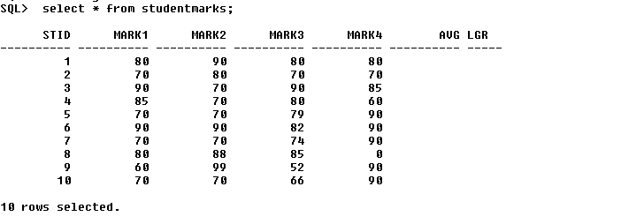

1. Use the following command to create the above table :-

Create table studentmarks (

Stid varchar2(10),

Mark1 number(3),

Mark2 number(3),

Mark3 number(3),

Mark4 number(3),

Avg number(10,3),

Lgr varchar2(10));

1. Use the following commands to insert the above data :-

Insert into studentmarks values (1,80,90,80,80,null,null);

Insert into studentmarks values (2,70,80,70,70,null,null);

Insert into studentmarks values (3,90,70,90,85,null,null);

Insert into studentmarks values (4,85,70,80,60,null,null);

Insert into studentmarks values (5,70,70,79,90,null,null);

Insert into studentmarks values (6,90,90,82,90,null,null);

Insert into studentmarks values (7,70,70,74,90,null,null);

Insert into studentmarks values (8,80,88,85, 0,null,null);

Insert into studentmarks values (9,60,99,52,90,null,null);

Insert into studentmarks values (10,70,70,66,90,null,null);

1. Write required PL/SQL blocks to do the following :-
   1. To find average mark and letter grade for all the students according to the following table. Use cursor.

|  |  |
| --- | --- |
| **Average** | **Letter Grade** |
| **80 ≤ Av ≤ 100** | **A** |
| **70 ≤ Av < 80** | **B** |
| **50 ≤ Av < 70** | **C** |
| **0 ≤ Av < 50** | **D** |

* 1. Update the student average and the letter grade according to the calculated values.
  2. Display the following report after performing the update process.

Stid M1 M2 M3 M4 Avg Letter Grade

----- ----- ----- ----- ----- ---- -------- --------------

declare

cursor cur_std is select * from studentmarks;

rec_std cur_std%ROWTYPE;

v_avg number(7,2);

v_lgr char(1);

begin

open cur_std;

loop

fetch cur_std INTO rec_std;

EXIT when cur_std%NOTFOUND;

v_avg := (rec_std.mark1 + rec_std.mark2 + rec_std.mark3 + rec_std.mark4)/4;

if v_avg > 80 then

v_lgr := 'A';

elsif v_avg > 70 then

v_lgr := 'B';

elsif v_avg > 50 then

v_lgr := 'C';

else

v_lgr := 'D';

end if;

dbms_output.put_line(rec_std.stid ||' ' ||rec_std.mark1||' '||rec_std.mark2||' '||rec_std.mark3||' '||

rec_std.mark4 ||' '|| v_avg||' '|| v_lgr);

update studentmarks set avg = v_avg, lgr = v_lgr where stid = rec_std.stid;

end loop;

close cur_std;

end;